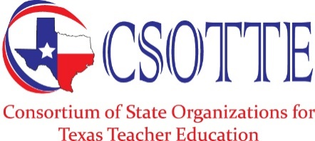 | Statement of Purpose
The Consortium of State Organizations for Texas Teacher Education (CSOTTE) is a nonprofit organization dedicated to the continual support and refinement of preparation and development programs for certificated school personnel in Texas.
CSOTTE serves as a coordinating organization of organizations for teacher education through which the member groups may:
- conduct continuing collaborative study of professional developments, concerns, problems, and issues of special significance to their members;
- engage in productive dialogue regarding matters of common interest;
- cooperate in such services as publications, meetings, research, and administration;
- devise common professional positions and joint strategies for implementing them; and
- undertake collective action.
CSOTTE also functions as an umbrella organization for the promotion of quality programs in teacher education by:
- preparing and disseminating ideas, practices, and programs;
- encouraging, supporting, initiating, conducting, and reporting programs of development and research;
- providing leadership through speaking out in support of teacher education;
- developing preparation guidelines for the profession and working with official policymaking groups and individuals to frame and promote professionally sound legislation, rules regulations, and structures for teacher education in Texas; and
- promoting the integration of individual teacher educators and the teacher education enterprise into full-fledged membership and component status, respectively, in the teaching profession.

Our Purpose
CSOTTE is dedicated to the support and refinement of professional preparation and development programs for all certified school personnel in Texas. CSOTTE will serve as the state voice of the education profession in all matters related to state and national educator preparation and certification.

